IV. Fill in the blank

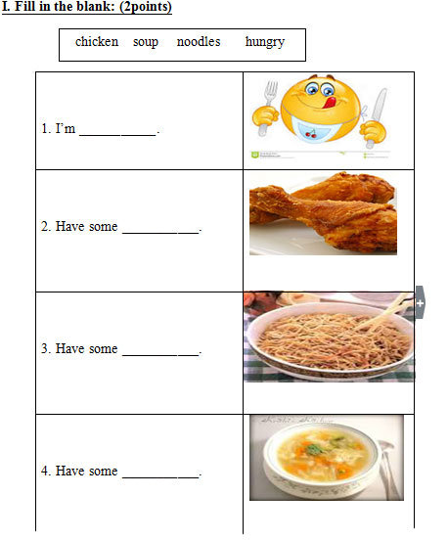

V. Circle the odd one out

A B C D
1. pillow bear blanket soup
2. candy wet cold hot
3. police officer farmer sunny doctor
4. chicken green soup noodles

VI. Check the correct sentence
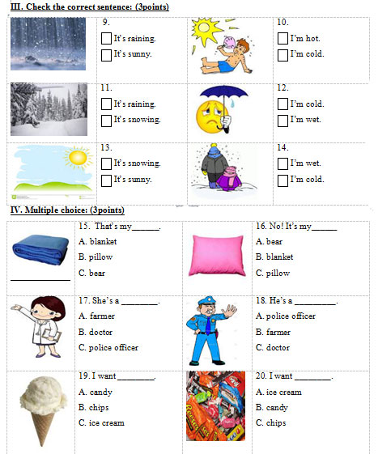

VII. Multiple choice

