REVIEW
There’s There are
I. Write
There’s
1. _______________ a doll on the rug.
2. _______________ three books under the bed.
3. _______________ a bed in my bedroom.
4. _______________ two pillows on my bed.
5. _______________ a shelf in my bedroom.
6. _______________ two cabinets in my bedroom.
7. _______________ a blanket on my bed.
8. _______________ lots of books on my shelf.
9. _______________ an elephant in the zoo.
10. _______________ an apple on the table.
11. _______________ two rugs in my kitchen.
12. _______________ flowers on the cabinet.
13. _______________ a TV in his living room.
14. _______________ birds in the zoo.
15. _______________ a picture on the wall.
II. Write: This, That, These or Those and complete the sentences.
table
This
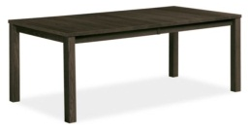
1. ______________ is a ______________.

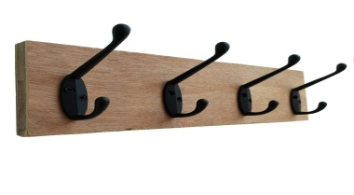
2. ______________ are ______________.

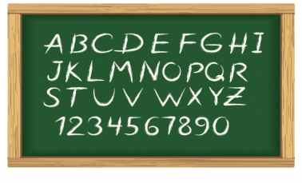
3. ______________ is a ______________.


4. ______________ are ______________.

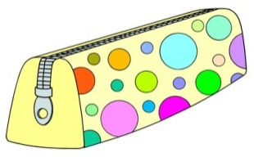
5. ______________ is a ______________.

6. ______________ are ______________.


7. ______________ are ______________.
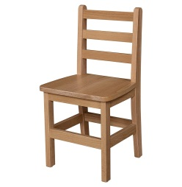

8. ______________ is a ______________.

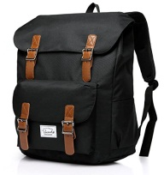
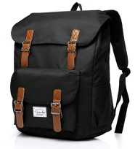
9. ______________ are ______________.

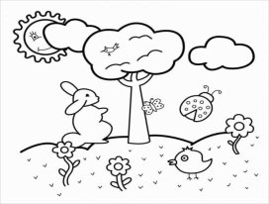
10. ______________ is a ______________.

III. Circle the correct answer.
1. This / These are tables and chairs.
2. That / Those is a new board.
3. These / This is my brother.
4. These / This are my friends.
5. Those / That is a frog.
6. Those / That are balloons.
7. This / These is a poster.
8. That / Those are big houses.
IV. Answer the questions.
1. Do you have a milkshake? 2. Do you have a pizza?
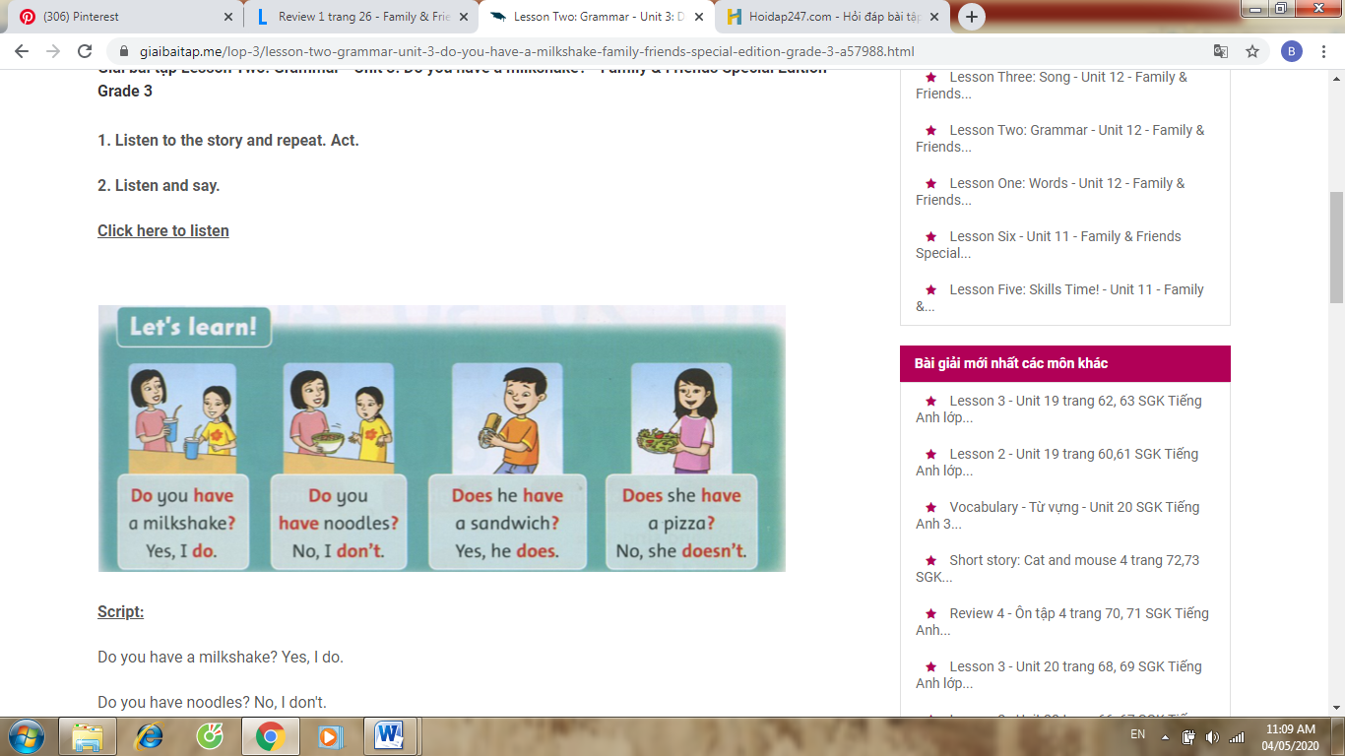

Yes,______________. ______________.
3. Does she have a sandwich? 4. Does he have noodles?

______________. ______________.

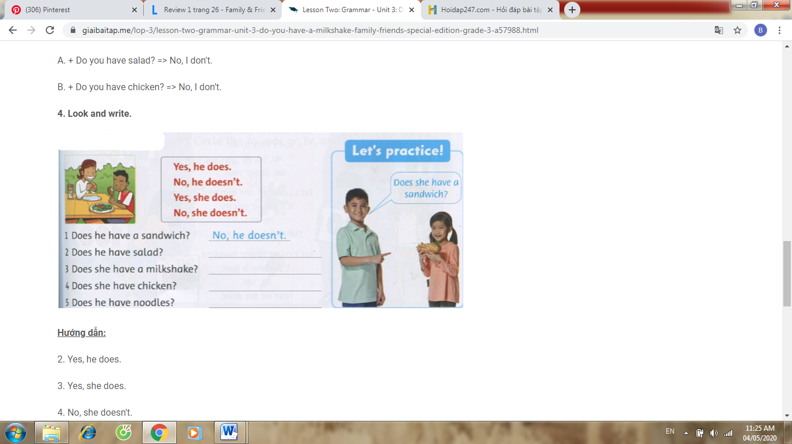
5. a. Does she have a sandwich? ______________.
b. Does he have a milkshake? ______________.
c. Does he have chicken? ______________.
d. Does she have a milkshake? ______________.
e. Does he have salad? ______________.
f. Does she have pizza? ______________.

6. a/ Do you like apples? ______________.
b/ Do you like mangoes? ______________.
c/ Do you like oranges? ______________.
V. Order the words.
1. a / you / have / Do / sandwich / ?
____________________________
2. he / milkshake / Does / ? / have / a
____________________________
3. doesn’t / have / salad / He / his / .
____________________________
4. lots / pictures / of / There / posters / are / wall / the / . / on / and
__________________________________________
5. school / This / my / is /.
____________________________
6. 12 / There / in / girls / and / are / 14 / class / my / boys /.
__________________________________________

7. sandwiches / like / the / They /.
____________________________
8. are / tables / your / These / chairs / . / and / new
__________________________________________
9. coat hooks / Those / new / are / .
____________________________
10. is / TV / There / on / cabinet / a / . / the
____________________________
11. is / new / pencil case / That / .
____________________________
VI. Circle the odd one out.
1. three doll eleven seven
2. pot pillow rug fox
3. teddy bear doll bug bike
4. computer truck train car
5. frog brush crab elephant
6. grapes grass oranges pears
7. salad chicken bread frisbee
8. poster drawers fifty picture
9. pencil case board cabinet hop
10.milkshake pizza dress noodles

VII. Read. Then, write T (true) or F (false) for each sentence.
My name’s Tim. This is my living room. There is a big table and there are five chairs. There is a TV on the cabinet. There is a picture of my family on the wall. There are lots of books on the shelf. They are my favorite books. I have two toy boxes. I like my living room.
*Write T/F
1. There are two tables. ______
2. There is a TV on the cabinet. ______
3. Tim has a toy box. ______
4. There is a poster on the wall. ______
5. Tim doesn’t have lots of books. ______
6. Tim likes his living room. ______

