REVIEW
I. Rearrange the letters.
chicken
1. c h k i c n e ___________
2. y n n u s ___________
3. o u p s ___________
4. o o n l d e s ___________
5. n s w o i g n ___________
6. w t e ___________
7. g n i n i a r ___________
8. t o h ___________
9. d l o c ___________
10. g n s n o i w ___________
11. b a l n e k t ___________
12. a r e b ___________
13. l i l p o w ___________
II. Look and write.
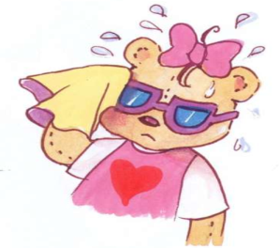
1. 2.
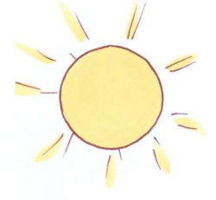

It’s _______________. I’m _______________.

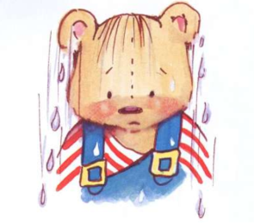

3. 4.

_______________. _______________.
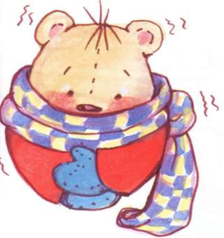
5. 6.


_______________. _______________.
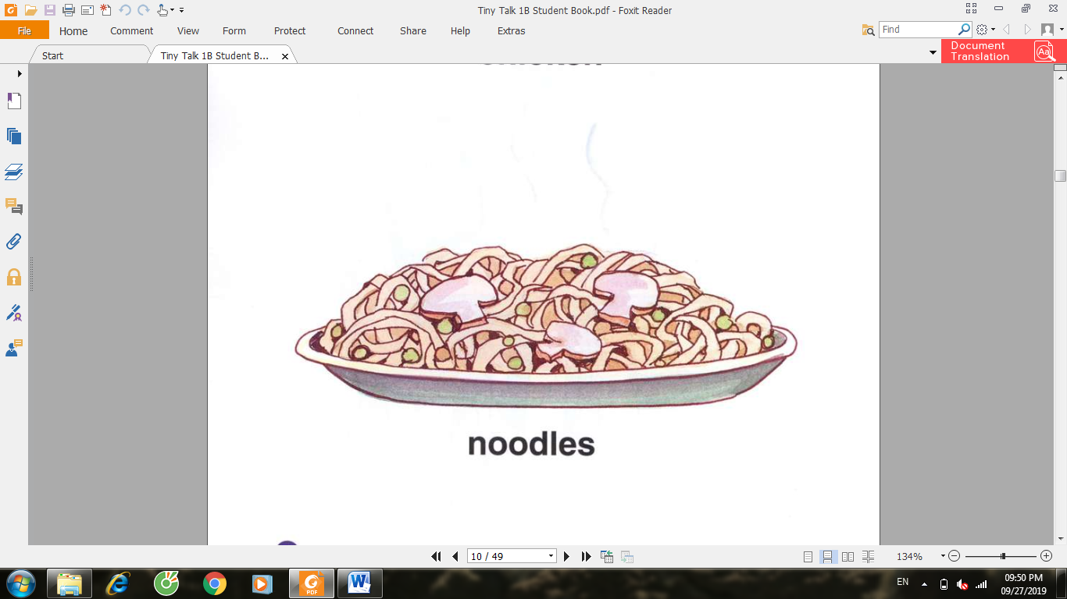
7. 8.
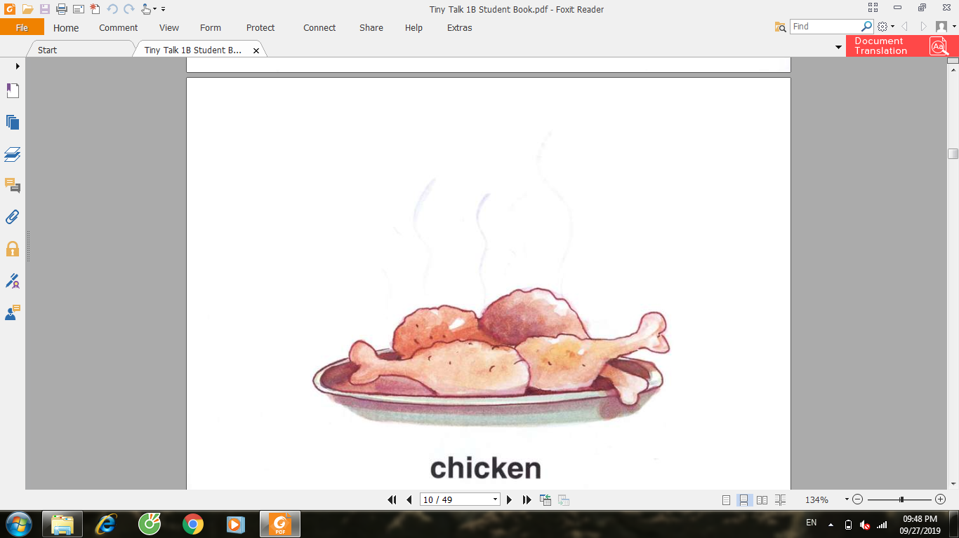

Have some __________________. ______________________.
9.
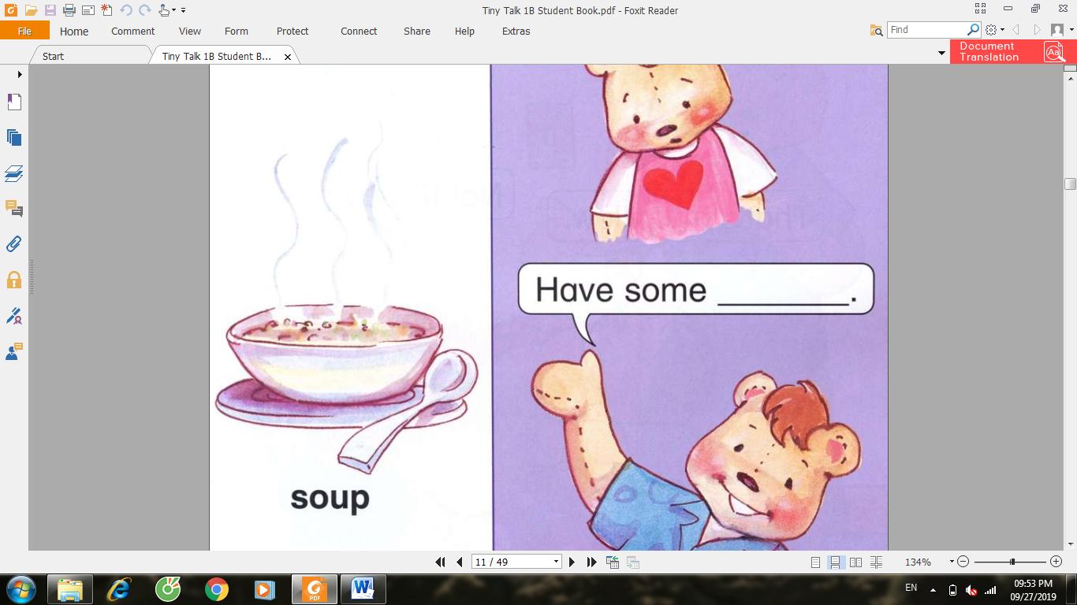
___________________________.

III. Unscramble and write.
1. my / That’s / bear
___________________________.
2. It’s / my / No! / bear.
___________________________.
3. Be / Shh! / quiet!
___________________________.
4. pillow / That’s / my
___________________________.
5. No! / my / pillow / It’s
___________________________.
IV. Check () the correct sentence.
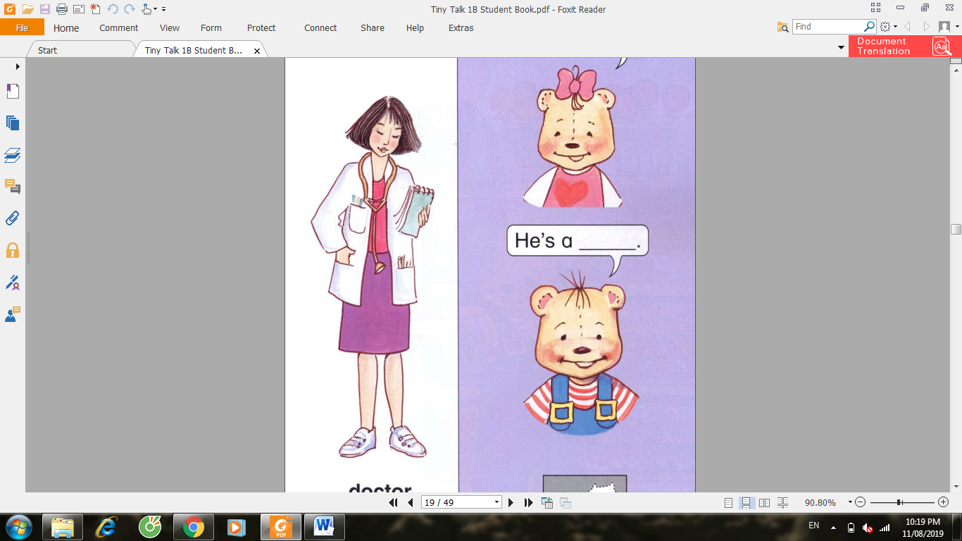

She’s a doctor.

She’s a farmer.

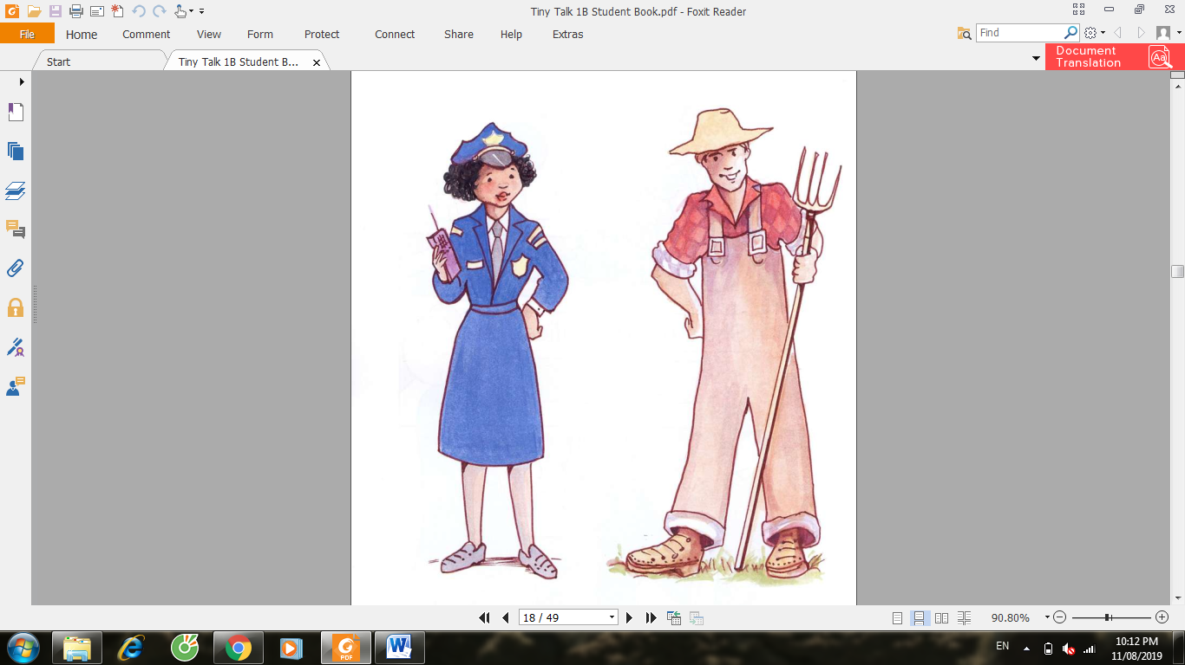
She’s a doctor.

She’s a police officer.

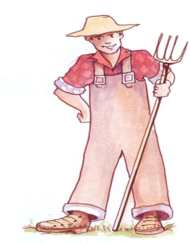
He’s a police officer.

He’s a farmer.


She’s a teacher.

She’s a student.


He’s a police officer.

He’s a farmer.

V. Fill in the blank.
1. It’__ ra__n__ng. I’__ w__t.
2. __’m h__ngry. Ha__e some no__dl__s.
3. __t’s s__nny. I’__ h__t.
4. H__ve s__me ch__cken. It’s go__d.
5. That’__ my p__ll__w. N__! It’s my p__ll__w.
6. That’__ m__ bl__nk__t.
7. No! It’s __y b__ar.
8. No! It’s my b__a__ke__.

