REVIEW

REVIEW 2
I. Write the correct word. Choose from the box. ( chọn từ trong khung viết vào tranh)
boy teacher Benny book
Miss Dolly Sue girl crayon

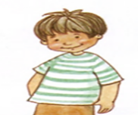  1.  boy | 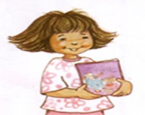  2.  _________________ | 3.  _________________ | 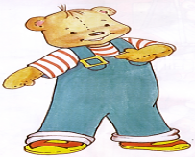  4.  _________________
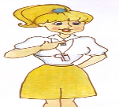  5.  _________________ |   6.  _________________ | 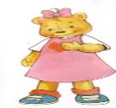  7.  _________________ | 8.  _________________

II. Complete the dialogues. ( hoàn thành bài hội thoại)
name
welcome
Fine
Hello
sorry

9.__________! My name’s Nga.
10. How are you? _______. Thank you.
11. Thank you. You’re_____________.
12. Ouch! I’m ____________.
13. What’s your name? My _______ is Benny.
III. Match ( nối)
- 1 quyển sách |  |  | - puppet
- Cô giáo |  |  | - boy
- Con rối |  |  | - Hello
- Bút sáp màu |  |  | - goodbye
- Bé trai |  |  | - a book
- Xin chào |  |  | - You’re welcome.
- Tạm biệt |  |  | - teacher
- Bé gái |  |  | h. crayon
- Cảm ơn |  |  | i. girl
- Không có chi |  |  | j. thank you.

IV. Unscramble (xếp lại cho đúng)
1. you / are / How /?/ → ………………………..........
2. thank / Fine, / you/./ → ……………………….................
3. girl / ‘m / I / a/./ →………………………............................................................
4. your /What / is/ name /./ →………………………...........................................................
5. name / is / Son / My /./ →……………………….............................................................
6. Benny. / morning, / Good / →……………………….............................................................

V. Complete the words:

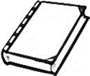  0 . Book | 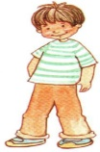  1. ___oy | 2. t___ac___er
 | 3. cra___on | 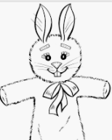  4. pup__et

VI. Matching. ( Nối)

1. Hi, I’m Benny. My name is Sue.

2. What’s your name? Hello, Benny.

3. Thank you. See you tomorrow!

4. Good-bye! You’re welcome..

The end.

